Homework Set #3
CSCE2114 – Digital Design
Fall 2016
Due: Monday, Sept. 26, 2016 (at the start of class)
45 Points

Show the details of your solutions.

1) Consider the circuit shown in Figure 1.
a) (5 points) Show the truth table for the logic function F and how you got it.
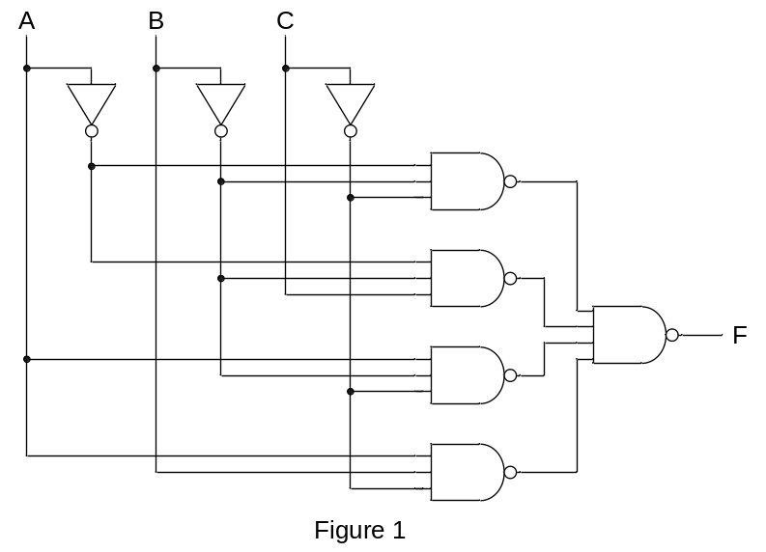b) (5 points) If each gate in the circuit is implemented as a CMOS gate, how many transistors are needed in total?

2) Consider the circuit shown in Figure 2.
a) (5 points) Show the truth table for the logic function F.
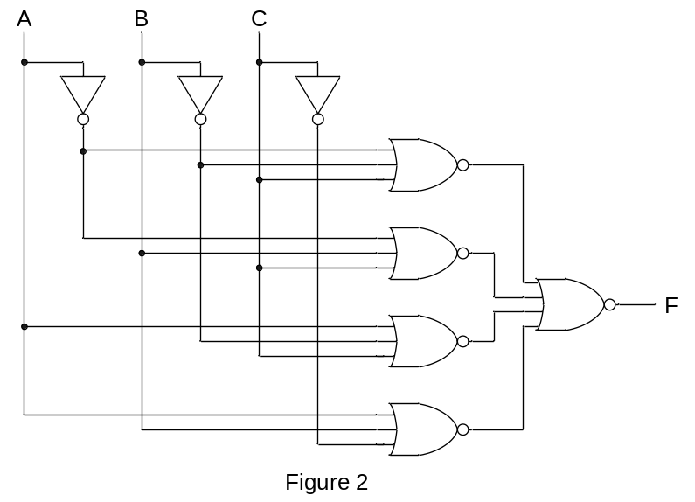b) (5 points) If each gate in the circuit is implemented as a CMOS gate, how many transistors are needed in total?

3) a) (5 points) Give the truth table for the circuit in Figure 3.
b) (5 points) Derive the canonical product-of-sums Boolean equation for the truth table
from part a.
c) (5 points) How many transistors does it take to implement the circuit from part b if
only AND, OR, and NOT gates are used?
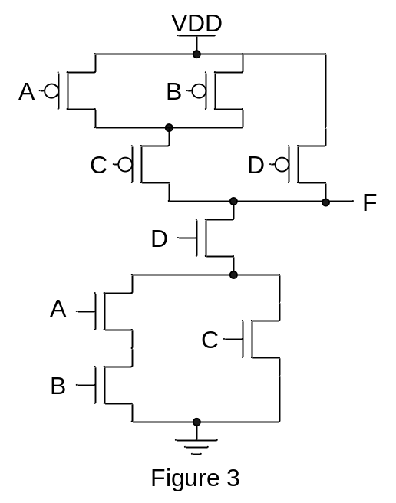

4) (5 points) Figure 4 shows half of a CMOS circuit. Derive the other half that
contains the PMOS transistors (the pull-up part).

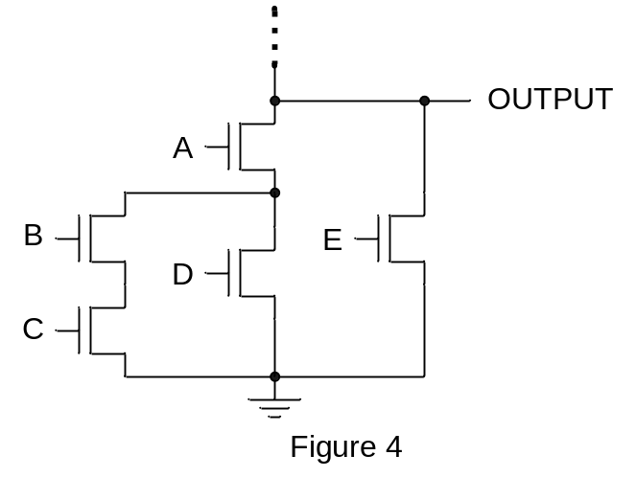

5) (5 points) Given F1(A,B,C) = Σm(0,3,4,5) show the programmed connections on the PLA diagram shown in Figure 5 and the canonical sum-of-products Boolean equation. F2 is not used.

